**Lab Sheet 10**

IT24102886

Perera R.S.K.

1. **Null Hypothesis (H0):** Customers choose the four snack types with equal probability. (P(A) = P(B) = P(C) = P(D) = 0.25)

**Alternative Hypothesis (H1):** At least one snack type has a selection probability that is not 0.25

1. 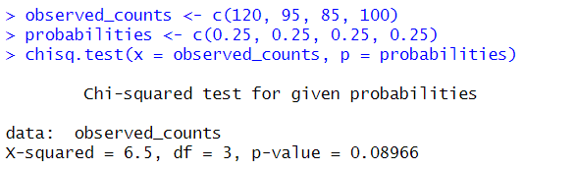
2. At the 5% significance level, the p-value (0.0897) is greater than 0.05. Therefore, the null hypothesis cannot be rejected. There isn’t sufficient statistical evidence to reject the owner's claim that all snack types are selected with equal probability.